# CHAPTER THREE

**MATERIALS AND METHODS**

## 3.1 Introduction

## This chapter details the procedure, materials, and methods used to achieve the established goals and objectives, as well as how these materials were utilized to achieve the desired results.

## 3.2 Materials

The materials used for the implemented system include Microsoft Word 2013, Arduino Integrated Development Environment (IDE), Proteus design suite, Arduino UNO board, PIR sensors, LDR, gas sensor, resistors, transistors, capacitors, relay, diodes, transformer, LEDs, GSM module, Wi-Fi module, power regulator, and the data used in the work of Olarewaju *et al.,* (2017).

## 3.3 Methodology

The methodology used to bring about the actualization of the intelligent home security system are as follows:

1. Design and implementation of a home security system based on the work of Olarewaju *et al.,* (2017) using these steps:
2. Design of the system model that consists of the software development steps and hardware design of the security system.
3. Writing the source code for the microcontroller to satisfy the requirements of the security system.
4. Implementation of (1a. and 1b) in an electronic circuit simulator.
5. Physical implementation of the security system on a breadboard and test the circuit.
6. Improvement of the implemented security system*,* by incorporating additional communication options (phone-call, and e-mail) and features (gas/fire sensor, security light, automatic door control) in the home security system.
7. Replacement of GSM module in the implemented home security system with a GSM/GPRS Module.
8. Design and implementation of the additional sensors (gas/fire sensor and LDR (security light) and other required components.
9. Writing the source code for the GSM/GPRS Module and the additional sensors to satisfy the requirements of the security system.
10. Implementation of (2a. and 2b) in an electronic circuit simulator, breadboard and veroboard
11. Running and debugging of the codes written in (c).
12. Running and debugging of the complete implemented home security system’s codes.
13. Uploading of the debugged codes onto the microcontroller.
14. Conducting performance test and evaluation of the security system using response accuracy, and reliability as performance metrics.

### 3.3.1 Design And Implementation of a Home Security System Based on the Work of Olarewaju *et al.,* (2017)

The steps involved in the replication of the work of Olarewaju *et al.,* 2017 are detailed in these subsections.

*3.3.1.1 Design of the system model and hardware design*

The design begins with a conceptual architecture, showing the intended relationship of sub-systems, and their synchronizations to bring about the expected result. The conceptual architecture of the home security system is as shown in Figure 3.1.

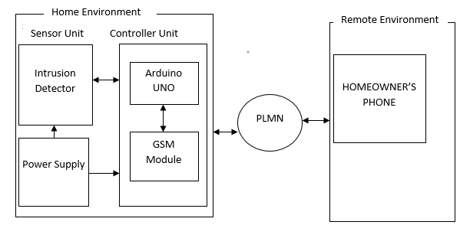

Figure 3.1: Conceptual Architecture of Home Security System (Olarewaju *et al.,*2017).

The security system is divided into two major sections. These are Hardware and Software.

*3.3.1.2 Software Implementation*

The software was implemented using the flowchart in Figure 3.2 as a guide on individual activity as executed.

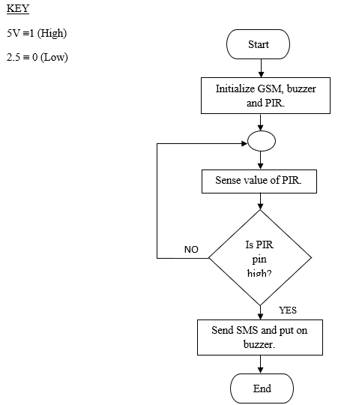

Figure 3.2: Flowchart of the Home Security of Olarewaju *et al.,* (2017)

*3.3.1.3 Hardware Design*

The hardware was further divided into power supply unit and security system unit.

**1. Power Supply Unit:** The power supply unit is made up of a 14V AC stepdown transformer with a 1A output current, a complete bridge rectifier, a voltage regulator (7805), and a filter. The security system's power requirement is 5V.

A. Design and selection of transformers:

With the help of the transformer, the 220V AC from the mains is stepped down to 14V AC. Equation (3.1) is used to compute the transformer's peak voltage output (Theraja, 2008).

$V_{peak}=\sqrt{2} ×V_{rms}$ (3.1) Where $V_{rms}=14V$

$V_{peak}=\sqrt{2}×14$ $V_{peak}=19.80V$

1. Rectifier diode design and selection:

For full wave rectification of the transformer output voltage, four 1N4001 diodes coupled in bridge were employed. IN4001 was chosen because its PIV (Peak Inverse Voltage) is 50V, which is more than $V_{peak}$, which is roughly 20V. (Sudeep and Mohammed, 2013).

$V_{dc}=\left(2∕π\right) ×V_{peak}$ (3.2)

but $V_{peak}=19.80V$

$V_{dc}=\left(2/π\right)×19.80$

$V_{dc}=12.61V$

1. Voltage regulation and filter design

A 5V regulator (LM7805) was utilized for the component of the home security system that required a 5V power source. The choice is based on the IC's ability to maintain a constant output voltage of 5V while providing up to 1A load current (alldatasheet.com, 2020). Under normal operating conditions, the LM7805 has a heat sink attached to it to channel the generated heat away from it.

It is desirable to select a filtering capacitor for the filter section that maintains peak-to-peak ripples (RF) at roughly 70% - 80% of the peak voltage (Thomas and Paul, 1995). The lower the ripple factor, the better the filter's performance. Therefore, using design specifications, the value of the capacitor can be calculated as follows:

From the relations (Thomas and Paul, 1995):

$Q=C ×V$ (3.3)

$Q=I ×T$ (3.4)

$f=\frac{1}{T}$ (3.5)

$I_{min}=I_{dc}=1A$

Here, C filters capacitor, Q loads in columns, I load current, T is second period and f is Hz frequency.

Using (3.3) and (3.4) equations and replacing the equation T (3.5) equations, returns:

$C= \frac{I}{Vf}$ (3.6)

However, V stands for peak-to-peak voltage, while RF stands for ripple factor. The equation (3.7) is used to compute its value (Theraja, 1998)

$V=RF × V_{rms}$ (3.7)

$\sqrt{2}× V_{m}$ gives $V_{rms}$ where $V_{m }$ is the system necessary voltage of 5V, the mains frequency is 50Hz and the RF is 70%.

Therefore

$V =0.7× \sqrt{2}×5$

V = 4.949 Volts

And $C =\frac{1}{4.949×50}$

$C$ = 4040µf

The standard available value is 4400f, which is achieved by connecting two 2200f in parallel.

The circuit diagram for the home security system's power supply unit is shown in Figure 3.3.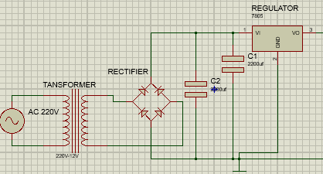

Figure 3.3: Circuit Diagram of Power Supply Unit

1. **Design of the main security controller** **unit:** A passive infrared sensor (PIR-045), LEDs, resistors, a GSM module (A6), and an Arduino UNO make up the hardware of the security system unit. As shown in Figure (3.4), the Arduino receiver pin (pin 0) is wired to the transmitter pin (pin Tx) of A6, the receiver pin (i.e. pin Rx) of A6 is attached to the transmitter pin(pin1) of the Arduino, and the signal pin (GPIO) of A6 is connected to Arduino pin 9.  The A6 requires 3.3V 20mA of power. PIR-045 is attached to Arduino's analogue pinA5. LED1 is connected to digital pin10, LED2 is connected to digital pin13, and LED1 is connected to digital pin10. To steady the current flowing through the LEDs, they were linked in series with resistors in a series connection.

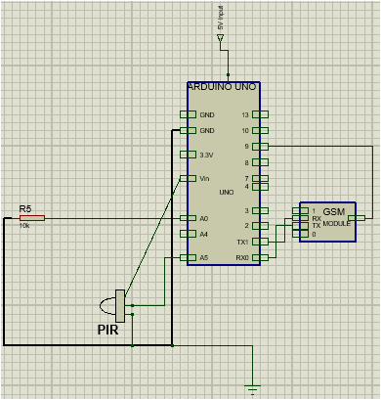

Figure 3.4: GSM and PIR circuit diagram connected to Arduino UNO.

The operating current I of LEDs is 20mA and the voltage drop $V_{f}$ is between 1.8V and 2.5V (a worst case is utilized in the design, 2.5V) (alldatasheet.com 2020). The supply voltage $V_{s}$ is 5V. (from Arduino pin). The value of the current limiting resistors can be calculated using these values. The value of the resistors R ($R_{1}$ and $R_{2}$) was calculated using Ohms law, equation (3.8) (Thomas and Paul, 1995), as shown.

$R=\frac{( V_{S}-{V }_{f })}{I}$ (3.8)

$R=\frac{(5-2.5)}{(20×{10}^{-3 })}$

$R=125Ω$

A standard value of 150 ohms was chosen for $R_{1}$ and $R_{2}$ based on the obtained value of 125 ohms. An amplifying circuit is required for the home-based alarm system (buzzer). A multifunctional NPN transistor (C1815) is required for the amplification circuit, along with a base resistor $R_{3}$ to give the transistor's base current. Equations (3.9) (Theraja, 1998) were used to compute the value of the resistor ($R_{3}$):

$R=\frac{( V_{S}-{V }_{f })}{I}$ (3.9)

Where V is the powered voltage from the Arduino UNO 5V, $V_{be}$ is the base-emitter voltage 0.7V and $I_{b}$ is the base current (500uA) ([alldatasheet.com](http://www.alldatasheet.com) 2019).

$R_{3}= \frac{5-0.7}{0.005}$

$R_{3}$ = 860Ω

A standard value of 1k Ω±20% was chosen from the obtained value of 860 ohms. Based on the work of Olarewaju et al., (2017). Figure 3.5 depicts the circuit diagram of the home security system's control unit.

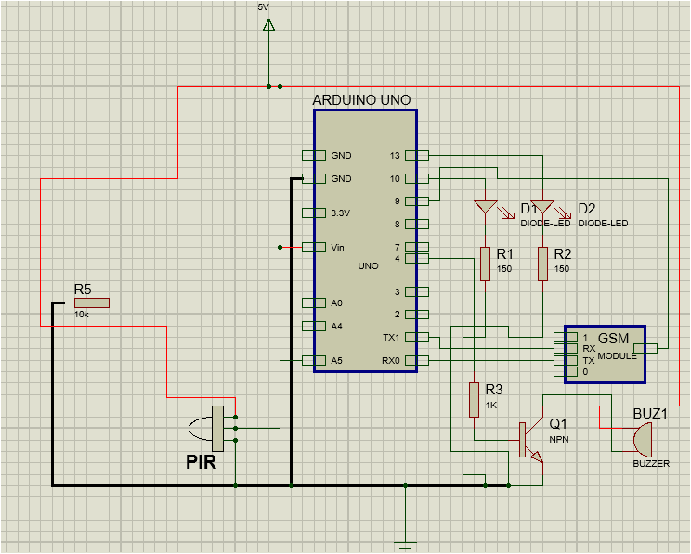

Figure 3.5: Circuit Diagram of the Control Unit (Olarewaju *et al.,* (2017))

*3.3.1.4 Writing Source code for the microcontroller Arduino UNO*

The source code was written to meet the needs of a security system with an Arduino UNO as the main controller. The Arduino IDE was used to create the software. The software was written using the flowchart in Figure 3.2 as a guide. The software for the process is presented in Appendix A.

*3.3.1.5 Simulation of the Designed Security System in an Electronic Circuit Simulator and Physical Implementation of the Security System on a Breadboard*

The designed system circuit was simulated in Proteus circuit simulator, other software’s needed to achieve an effective running of the simulation where also uploaded, to ensure compliance with design specifications. The system was then implemented on a breadboard for further testing and verifications. Figure 3.6 shows the complete circuit design as implemented.

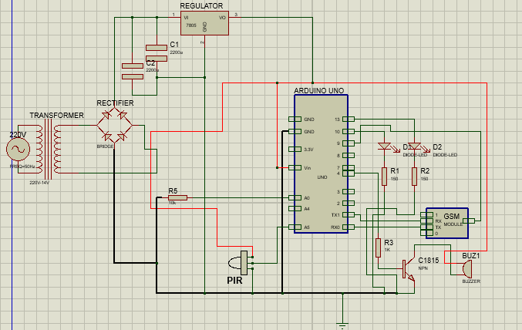

Figure 3.6: Complete Circuit Diagram of Home Security System (Olarewaju *et al.,* 2017)

### 3.3.2 Improvement of the Developed Security System*.*

The steps involved in improving the implemented security system, are detailed in this subsection.

### *3.3.2.1 Replacement of the GSM Module in the Security System Circuit with a GSM/GPRS Module*

The designed security system, at this stage can only give indication in terms of an SMS alert and a buzzer coming on. Replacing the GSM Module with a Bluetooth/GSM/GPRS (SIM800) module will make the home security system more versatile, once supported by a well written code for its operation. Alerts can be received in form of calls, SMS, and e-mail. The pin connection of A6 is directly replaced with pin connection for SIM800 as in Figure 3.4. The Arduino's receiver pin (pin0) is connected to the SIM800's transmitter pin Rx, and the SIM800's transmitter pin Tx is connected to the Arduino's receiver pin pin1. The SIM800's signal pin GPIO is connected to pin9 of Arduino modules. SIM800 requires 3.3V-4.2V 500mA (worst case) for proper operation.

*3.3.2.2. Design and Implementation of Additional Sensors and Components into the Security System*

To improve the functionalities of the security system, additional sensors and components were introduced. These include a gas/smoke sensor (MQ2), a servo motor (sg90), an LDR, a security light and a Wifi module. The design of these sensors is detailed.

1. **Design of the security light circuitry:** The security light is an additional home-base alert system. It requires a switching circuit (relay driver circuit), which is made up of resistor, 12V relay, a diode (1N4007) and transistor (C1815). A base resistor R is connected to a multipurpose NPN transistor (C1815). The transistor's base current is provided by the resistor. Equations (3.9) was used to compute the value of the resistor ($R_{4}$) Where V is the Arduino UNO's 5V output voltage, $V_{be}$ is the 0.7V base-emitter value, and $I_{b}$ is the base current (500uA) (Thomas and Paul,1995).

$R_{4}= \frac{5-0.7}{0.005}$

$R_{4}$ = 860Ω

A standard value of 1k Ω ± 20% was chosen from the obtained value of 860 ohms. The collector current is used to drive the relay. A free-wheeling diode is connected in reverse bias to the relay to shunt to the ground the back EMF from the relay. The 1N4007 diode was chosen because it has a high PIV (peak inverse voltage) of about 1,000V (alldatasheet.com 2020). Figure 3.7 shows the security light circuitry.

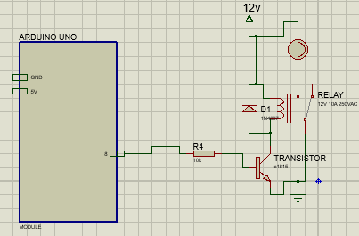

Figure 3.7: Circuitry of the Home Security Light System

1. **LDR design and selection:** The LDR circuit serves as brightness / visibility detection circuit, LDR is a component that has a variable resistance that changes with light intensity that falls upon it. The LDR pin is connected to analogues pinA0 of the Arduino module. LDR is connected to a voltage divider circuit, it is connected such that output voltage decreases as light increases. Equation (3.10) (Theraja, 1998) was used, where $V_{in}$ is the input voltage from power supply 5V, $R_{s}$ the measured resistance of the LDR ranges between 10KΩ to 500Ω, decreasing with brightness. $R_{5}$ is the divider resistance, and $V_{out}$ is the threshold voltage set for the Arduino input at pinA0 (2.5V – 5V) with 2.5V programmed to indicate darkness and 5V indicates brightness.

$V_{out}=\frac{R_{5}}{R_{s}+R_{5}}×V_{in}$ (3.10)

At full darkness when the value of $R_{s}$ is 10KΩ so using equation (3.10).

$2.5=\frac{R_{5}}{10000+R_{5}}×5$

$25000 =2.5R_{5}$

$R_{5}=10000$ Ω

At full illumination level $R_{s}$ is 500Ω using equation (3.10)

$V_{out}=\frac{10000}{10000+500}×5$

$V_{out}≈5V$

The value of $R_{5}$ is chosen to be 10KΩ so that the output value is halved only when the value of $R_{s}$ approaches 10KΩ, which is the designed trigger value.

1. **Connections of the improved version of the system:** The servo motor (sg90) signal pin is connected to pin7 of the Arduino module, MQ2 signal pin is connected to pin A4 of the Arduino and the Wifi module Tx and Rx pins are connected to pin11 and pin 12 of the Arduino module and its GPIO5 pin is connected to the Arduino pin6. Figure 3.8 shows the circuit diagram of the additional sensors and SIM800 implemented.

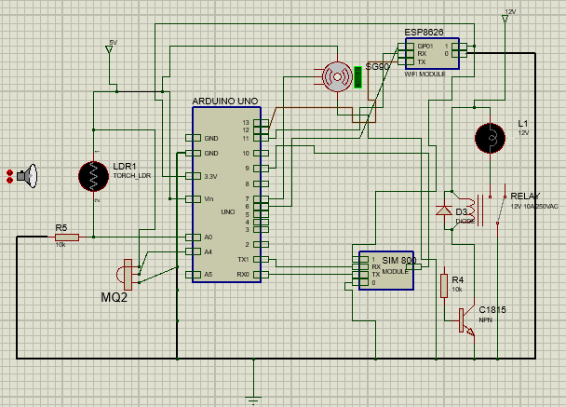

Figure 3.8: Circuit Diagram of Additional Sensors and SIM800

*3.3.2.3 Writing the Source Code for GSM/GPRS Module and the Additional Sensors to Satisfy*

*the Requirements of the Improved Security System.*

Software implementation of the improved home security system, was further divided into three units:

1. Surveillance unit
2. Security door unit
3. Safety unit

The activities of all the units are illustrated with flowcharts in Figures (3.9), (3.10) and (3.11) respectively.

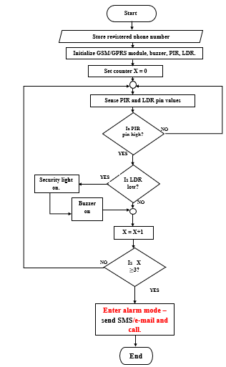

Figure 3.9: Flowchart of the Surveillance Aspect of the Home Security System

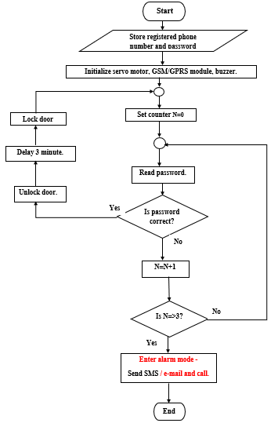

Figure 3.10: Flowchart of the Automatic Door of the Home Security System

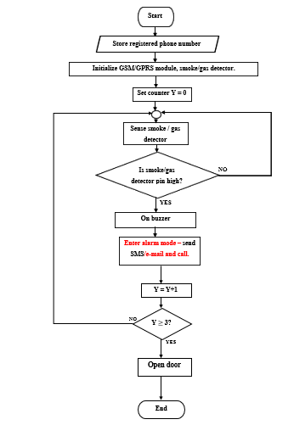

Figure 3.11: Flowchart of the Safety Aspect of the Home Security System

The code for the replaced module and the additional components is presented in Appendix B.

* + - 1. *GSM Module Replacement and Introduction of Additional Sensors in the Security System in an Electronics Simulator*

The designed circuit was simulated with a circuit simulator -Proteus with the software uploaded. Figure 3.12 shows the complete circuit design.

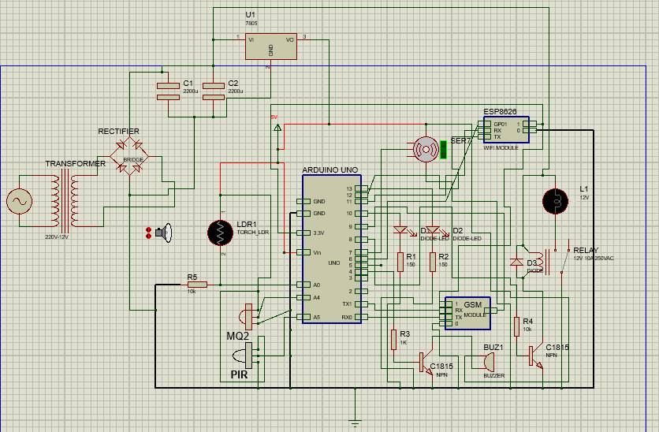

Figure 3.12: Complete Circuit Diagram of the Improved Home Security System

* + 1. **Evaluation of the Implemented Work and Comparison with the Work of**

**Olarewaju *et al.,* (2017)**

### *3.3.3.1 Computation of Reliability of the System*

The relationship between the reliability test and the time to failure test can be used to compute the reliability test of a system. During this test, data values are recorded that can be used to create a cumulative function, F(t). Equation 3.12 (Akinola, 2017) expresses reliability explicitly:

F (t) = 1 – R (t) (3.12)

Here, F(t) is failure rate and R(t) is reliability.

The part count failure rate approach is used to calculate the reliability of a home security system. This method necessitates data such as part category, quantity, and quality factor. Equation (3.13) defines the system failure rate (Bot *et al*., 1997). where $F_{i}$ is the ith part's failure rate, n is the number of part categories, $N_{i}$ is the part's quantity, and $π_{Q_{i}}$ is the ith part's quality factor.

$F =\sum_{i=1}^{n}{N_{i}F_{i}π_{Q_{i}}}$ (3.13)

The failure rate of each unit was calculated using equation (3.13) and data from the electronic equipment guide table on reliability prediction (Bot *et al*., 1997). Table 3.1 shows the calculated failure rate of the security system. The value of the system's reliability was calculated using Equation 3.12.

Table 3.1: Calculated Failure Rate of the Home Security System

|  |  |  |  |  |  |  |  |
| --- | --- | --- | --- | --- | --- | --- | --- |
| S/N | Components | Fi / ${ 10}^{6}$ hours | | N (category) | Ni (units) | $$π_{Q_{i}}$$ | F ${10}^{-5}$/ ${10}^{6}$ hours |
| 1 | Resistors | 0.000196 | 2 | | 6 | 0.03 | 7.056 |
| 2 | Capacitors | 0.000002 | 1 | | 3 | 0.01 | 0.006 |
| 3 | ICs | 0.73 | 2 | | 3 | 0.0043 | 1883.4 |
| 4 | Microcontrollers | 0.015 | 1 | | 1 | 2.4 | 3600 |
| 5 | Transistor | 0.00074 | 1 | | 2 | 8.0 | 118.4 |
| 6 | Semiconductors | 0.0038 | 1 | | 4 | 8.0 | 1216 |
| 7 | Mechanical device | 0.083 | 1 | | 2 | 0.103 | 1709.8 |
| 8 | Sensors | 0.040 | 1 | | 3 | 0.7 | 8400 |
| 9 | Modules | 0.028 | 1 | | 2 | 0.26 | 1456 |
| 10 | Inductive devices | 0.0030 | `2 | | 2 | 0.30 | 360 |
| 11 | Connector | 0.040 | 1 | | 2 | 0.659 | 5272 |
| 12 | Contact/Hand soldering | 0.0064 | 1 | | 33 | 0.0013 | 27.456 |
| 13 | Total failure rate of the system |  |  | |  |  | 24050.118 |

From Table 3.1. the predicted failure rate of the home security system was computed to be $24,050.118 ×{10}^{-5}/{10}^{6}$ hours, the complete computation is shown in Appendix C. Using equations 3.12, reliability of the home security system was computed.

$R\left(t\right)=1-0.24050118$

$R\left(t\right)=0.75949882$

$R(t)≈0.76$

*3.3.3.2. Performance Evaluation Compared to the Olarewaju et al,* 2017.

The performance of the implemented home security system and the work of Olarewaju *et al*., 2017 was compared using percentage of improved system performance with respect to SMS delivery, e-mail delivery and amount of establish phone connections. The comparison was done using equations (3.14), where $S_{N }$ is successfully delivered alert of the newly implemented home security system and $S_{O}$ is successfully delivered alert based on Olarewaju *et al.,*2017 work within the test period.

Percentage improvement = $\frac{S_{N}-S_{O}}{S_{O}}×100\%$ (3.14)